MARINE LIFE - Distribution of life in the sea
Name ________________________________________ Period __________________

The oceans may be divided into large biomes, or living regions (Figure 1). These zones are based on the distribution of marine organisms. The two major environments are the pelagic, which consists of the water column, and the benthic, which comprises the ocean bottom.

The pelagic environment is further subdivided into the neritic environment which overlies the continental shelf and the oceanic environment which overlies the ocean basins. The subdivisions are based on water depth. Many of the boundaries are, in part, determined by physical and/or chemical conditions, i.e., the distribution of a particular marine organism is controlled by a limiting factor which can be biological, physical or chemical.

The organisms that live in these zones can be classified in terms of the habitat they occupy.

Habitat Characteristics for Pelagic and Benthic Organisms:

Habitat | Characteristic
Pelagic = water zone  Nektonic  Planktonic  Holoplankton  Meroplankton | Swimming organisms  Floating organisms  Floating organisms for entire life cycle  Floating organisms for only part of life cycle, benthic or nektonic for the rest of life cycle
Benthic = ocean bottom  Sessile  Infauna or inflora  Epifauna or epiflora  Vagrant | Organisms that live in one place  Organisms that freely move on the ocean bottom  Animals or plants that grow in sediments or rocks  Animals or plants that grown on the sediments or attached to rocks or other objects
stenothermal  eurythermal  stenohaline  euryhaline | can only tolerate a limited range of temperature  can tolerate a wide range of temperature  can only tolerate a limited range of salinity)  can tolerate a wide range of salinity

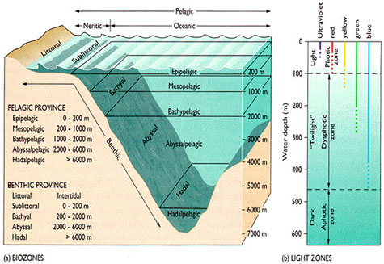

Answer the following questions in terms of physical and/or chemical factors that might explain, or partially explain, various divisions in the Hedgpeth (Figure 1) classification.
- The division between the epipelagic and mesopelagic zones.

- The division between the mesopelagic and bathypelagic zones. This boundary is about 1000 meters deep, and it is a level at which many physical and chemical changes occur.

- The division between the supralittoral (above high tide) and littoral zones.

- The division below the sublittoral zone.

- Why is there no boundary at about 1000 meters in the benthic environment but a significant one at about the same depth in the pelagic environment? Think of what the main control on the benthic organisms might be that the pelagic organisms would not have to contend with, and vice versa.
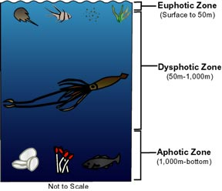
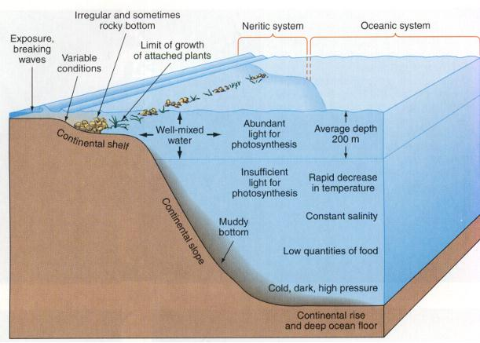

II. Primary productivity

All life in the ocean depends on the production of organic matter by primary producers. In the near- surface waters the primary producers are green plants which convert carbon dioxide and water into organic matter using sunlight as the energy source (photosynthesis). In simplified form, the photosynthetic reaction is written as follows

6CO2 + 6H2O + sunlight C6H12O6 (carbohydrate) + 6O2

In this reaction carbon dioxide and water vapor are converted to simple sugars and oxygen. The energy required for metabolic activity is derived by reversing this reaction (respiration), i.e., oxygen and sugar react to release energy, carbon dioxide and water. In the case of the primary producers (also referred to as autotrophs), if photosynthesis exceeds respiration there is a net gain in biomass. While photosynthesis is the primary pathway used to create organic matter, the required energy can also be obtained through chemical reactions (chemosynthesis). In the ocean, this pathway occurs at deep sea hydrothermal vents where primary producers obtain their energy through the oxidation of hydrogen sulfide, released by the hydrothermal solutions, to sulfur and sulfate.

There are several types of productivity. Primary productivity is the conversion of inorganic compounds into organic compounds. Gross primary productivity is the total amount of organic material synthesized during photosynthesis or chemosynthesis. Net primary productivity is the difference between the gross productivity and the amount of organic material used during respiration.
Primary Production

The factors that affect primary productivity are (1) the availability of light, (2) the availability of
nutrients and (3) the rate of grazing by primary consumers (herbivores).

The length of daylight and the angle of the sun in the sky determine the availability of light. At high sun angles light penetrates deeper into the ocean. The photic zone is the layer of a body of water that receives adequate sunlight for photosynthesis. Besides the length of daylight and sun angle, the depth of the photic zone is also affected by the abundance of particles in the water column. In regions of high productivity, abundant phytoplankton near the surface block much of the sunlight from the deeper depths. The same would be true for a region where there was high input of terrigenous particles.

Nutrients elements are consumed in the surface waters by phytoplankton. The nutrient elements are then removed from the surface waters by the passage of fecal pellets or the settling of dead organisms to greater depths. As the fecal pellets and organisms descend they break down and the nutrient elements are released to the water column. The result is that the concentration of nutrient elements increases with depth until a steady state value is reached. The availability of these
nutrients elements in the surface waters, in most cases, is the limiting factor in primary productivity.

The surface waters are replenished in nutrient elements by (1) upwelling of nutrient-rich deep water (either coastal upwelling due to Ekman transport or an ocean-wide upwelling due to diverging surface currents), (2) runoff and mixing from the land and (3) additions from the atmosphere. Of these three processes, upwelling is by far the most important.

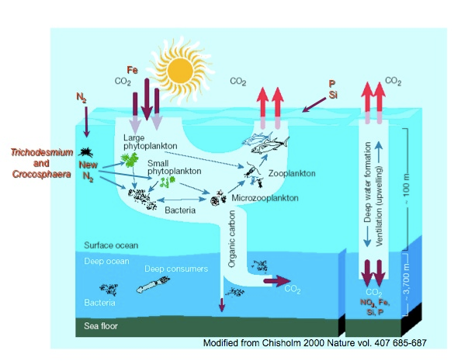

The rate of grazing by herbivores is a function of the availability of phytoplankton. As the number of phytoplankton increase the number of herbivores and grazing increases. Ultimately a point is reached where over-grazing occurs and the number of phytoplankton decline. This is followed by a decrease in the number of herbivores.

Seasonal variations in nutrient elements, plankton biomass and light for a mid-latitude oceanic region

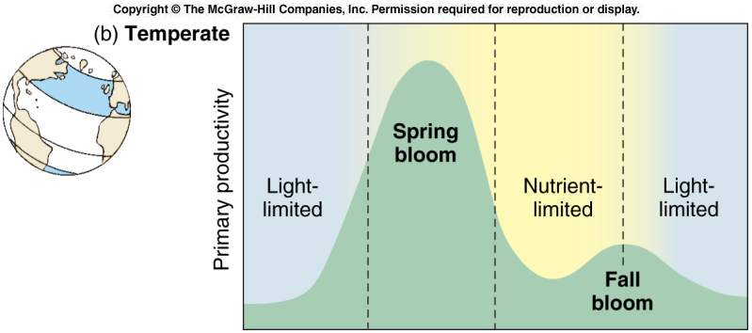

`

- Why do the dissolved nutrients drop in the spring?

- Why does the spring phytoplankton bloom start in the spring and die out in the early summer?

- Why is there a difference in the steepness of the zooplankton biomass curves during the spring bloom?

- What are some possible reasons for a fall phytoplankton bloom?

- Where on earth would the plankton show a different seasonal pattern of growth and why?

