- A triangular prism is 8 cm wide, 7 cm high, and 5 cm long.
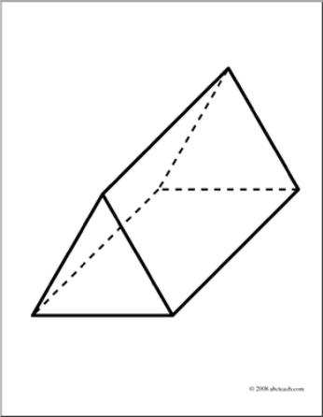
- Draw a net of the shape.
- What is the surface area?

- Sea salt is shipped in cylindrical, plastic containers. The diameter of the container is 2 ½ inches.
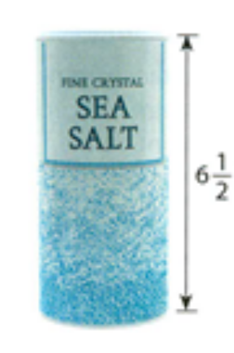
- Sketch a net of the salt container. Label all dimensions.
- A graphic artist is creating a new design for the label that wraps around the container. Calculate the maximum area for the label, to the nearest square inch.
- Calculate the total area of the plastic needed to make one container, to the nearest square inch.

- A cylinder has a diameter of 3 feet, and a height of 10 inches. What is the surface area of the cylinder?

- A standard hockey puck is 1” thick with a 3” diameter.
- Draw a net for the puck.
- What is the surface area of one puck?

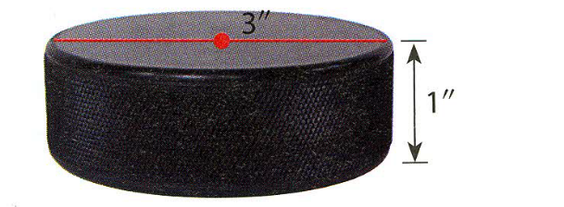


- Maggie has a cube-shaped box that she wants to gift wrap. Sheets of wrapping paper come in 3 sizes. Which size should Maggie buy? Explain your choice.

Size A: 30 cm by 30 cm
Size B: 60 cm by 40 cm
Size C: 90 cm by 50 cm

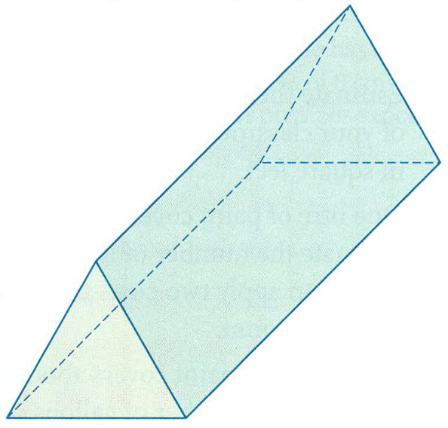
- A manufacturer makes a glass triangular prisms that refract light into the colours of the rainbow. The manufacturer protects each triangular prism with bubble wrap.
- Draw a net of the prism.
- Calculate the surface area of the prism.

