**Chapter 1 Test Review Questions**

**Multiple Choice**

*Identify the choice that best completes the statement or answers the question.*

____ 1. A two-dimensional pattern that can be folded into a three-dimensional shape is a:

|  |  |  |  |
| --- | --- | --- | --- |
| a. | net. | c. | prism. |
| b. | lateral face. | d. | grid. |

____ 2. Surface area is:

|  |  |
| --- | --- |
| a. | the amount of matter contained in a three-dimensional object. |
| b. | the area covering the surfaces of a three-dimensional object. |
| c. | the amount of space occupied by a three-dimensional object. |
| d. | the area covered by a two-dimensional object. |

____ 3. What three-dimensional shape would the following net create?



|  |  |  |  |
| --- | --- | --- | --- |
| a. | A rectangular prism. | c. | A right rectangular prism. |
| b. | An oblique prism. | d. | A triangular prism. |

____ 4. What is the surface area of this triangular prism?



|  |  |  |  |
| --- | --- | --- | --- |
| a. | 1871.6 cm2 | c. | 2807.5 cm2 |
| b. | 2339.56 cm2 | d. | 1403.7 cm2 |

____ 5. A rectangular prism has bases that are 8 cm long and 6 cm wide. The lateral faces are 15 cm long. What is the surface area?

|  |  |  |  |
| --- | --- | --- | --- |
| a. | 516 cm2 | c. | 568 cm2 |
| b. | 464 cm2 | d. | 413 cm2 |

____ 6. A crate with no lid is shaped like a cube with sides that are 0.8 m long. What is the surface area of the crate?

|  |  |  |  |
| --- | --- | --- | --- |
| a. | 2.6 m2 | c. | 2.9 m2 |
| b. | 3.5 m2 | d. | 3.2 m2 |

____ 7. What is the surface area of triangular prism shown below? The triangular ends of the prism are open.



|  |  |  |  |
| --- | --- | --- | --- |
| a. | 9270 cm2 | c. | 8343 cm2 |
| b. | 12051 cm2 | d. | 11124 cm2 |

____ 8. When sand is poured into a pile, it is most likely to form the shape of a:

|  |  |  |  |
| --- | --- | --- | --- |
| a. | sphere. | c. | cylinder. |
| b. | cone. | d. | pyramid. |

____ 9. Which of the following shapes does not have a curved surface?

|  |  |  |  |
| --- | --- | --- | --- |
| a. | sphere | c. | cylinder |
| b. | cone | d. | pyramid |

____ 10. What is the surface area of this cylinder?



|  |  |  |  |
| --- | --- | --- | --- |
| a. | 413.0 m2 | c. | 619.5 m2 |
| b. | 516.2 m2 | d. | 84.9 m2 |

____ 11. What is the surface area of a sphere with a radius of 5.5 cm?

|  |  |  |  |
| --- | --- | --- | --- |
| a. | 456.2 cm2 | c. | 342.1 cm2 |
| b. | 380.1 cm2 | d. | 418.1 cm2 |

____ 12. A square-based pyramid has base side lengths of 38 feet and a slant height of 24 feet. What is the surface area of its sides, not including the base?

|  |  |  |  |
| --- | --- | --- | --- |
| a. | 3648 ft2 | c. | 912 ft2 |
| b. | 1824 ft2 | d. | 456 ft2 |

____ 13. What is the surface area of this cone?



|  |  |  |  |
| --- | --- | --- | --- |
| a. | 1206 cm2 | c. | 1568 cm2 |
| b. | 1447 cm2 | d. | 844 cm2 |

____ 14. What is the surface area of the lateral face of a cone with a radius of 26 feet and a slant height of 37 feet?

|  |  |  |  |
| --- | --- | --- | --- |
| a. | 2115 ft2 | c. | 3022 ft2 |
| b. | 3626 ft2 | d. | 3929 ft2 |

____ 15. A storage shed has a roof that is a square-based pyramid. The sides of the shed are 33 m wide. The slant height of the pyramid is 39 m.

How many 1.1 m2 shingles are needed to cover the lateral surfaces of the roof?

|  |  |  |  |
| --- | --- | --- | --- |
| a. | 2344 | c. | 2339 |
| b. | 2341 | d. | 2340 |

____ 16. What is the surface area of a dome (half a sphere) with a radius of 57 metres?

|  |  |  |  |
| --- | --- | --- | --- |
| a. | 30574 m2 | c. | 30671 m2 |
| b. | 30621 m2 | d. | 30771 m2 |

**Short Answer**

1. Draw a net for the three-dimensional shape shown below.



2. Gina is planning to reupholster her couch cushions. The cushions are rectangular, 8 inches high, 31 inches long, and 29 inches wide. How much fabric will she need for each cushion?

3. Draw and label a net of a rectangular box with no lid, which is 1.5 ft feet high, 2.9 ft feet long, and 1.7 ft feet wide.

4. Spot has outgrown his puppy crate. His owner is going to make more room for Spot in the crate by removing the top and the front door.

The dimensions of the original crate are shown below. What will the surface area of the bed be once the top and front are removed?



5. Find the surface area of a square-based pyramid with a base length of 120 feet and a slant height of 175 feet.

6. Find the surface area of a cone with a radius of 3.6 cm and a slant length of 12.4 cm.

7. A grain silo is in the shape of a cylinder, and it has a dome-shaped roof. It has the following dimensions:

*r* = *3.5* m2

*h* = *20* m2

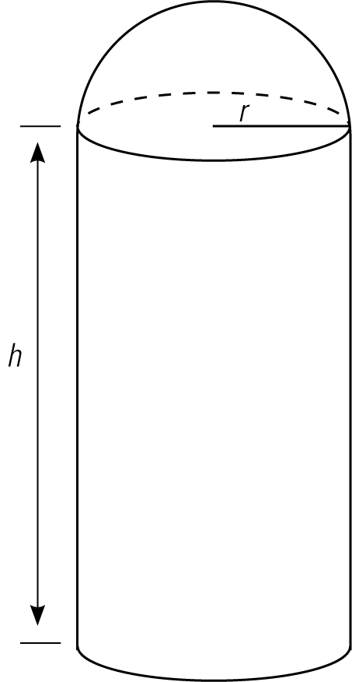

It is being repainted. What is the surface area that will need to be painted?

**Problem**

1. A crate is 5 feet long, 3 feet wide, and 2.5 feet high.

a) Draw and label a diagram of the crate.

b) What is the surface area of this crate?

c) What would be the surface area if the height of the crate was doubled?

2. A swimming pool is 6.5 feet deep, 24 feet wide, and 15 feet long. The whole pool is same depth.

a) What is the surface area of the pool?

b) If the pool is being repainted and each can of sealing paint covers 160 square feet, how many cans of paint will be needed?

3. A triangular prism has a bases that are equilateral triangles. The base equilateral triangles have sides of 9 inches and a height of 7.8 inches. The prism is 19 inches long.

a) Draw the prism and label all dimensions.

b) Draw a net of the prism and label the dimensions.

c) What is the surface area of this prism?

d) If you wanted to build this prism out of regular 8.5 by 11 inch pieces of paper, how many pieces of paper would you need?

4. A house has an L-shaped floor plan. The dimensions are as shown in the diagram.

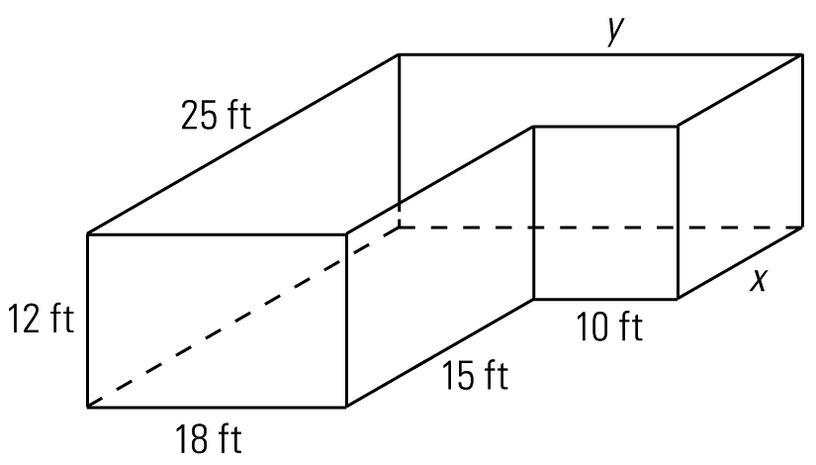

a) Calculate the lengths of walls *x* and *y.*

b) What is the surface area of the exterior walls of the house?

c) The owners will be repainting the interior of the house. What is the surface area of the ceiling? (Assume the interior surface area is the same as the exterior area, and that there are no walls within the house.)

5. A museum is restoring the front of a temple so that it can be displayed at the museum.

The temple has several cylindrical columns, each one with a diameter of 18 inches and a height of 16 feet. They are anchored to the floor, but the tops of the cylinders are exposed (there is no ceiling above them).

a) Calculate the exposed surface area of each column.

b) Each column will be wrapped in wire netting for the journey to the museum, so that it does not get damaged. If each roll of wire netting is 60 square feet, how many rolls will be needed to cover all 17 columns?

6. An ice cream store makes two sizes of waffle cone. They both have a slant height of 17 cm, but the small size has a radius of 2.4 cm and the large has a radius of 3.9 cm.

a) What is the area of dough that is used to make the small cone?

b) What is the area of dough that is used to make the large cone?

c) How much dough is needed to make 27 small cones and 12 large cones?

7. An amusement park is building a pyramid-shaped gift shop. The base will be square, with a side length of 12 m. The height at the apex of the pyramid is 5 m.

a) What is the slant length of the pyramid?

b) What is the total surface area of the pyramid?

c) What is the area of the gift shop that would need to be covered in siding?

8. A children’s basketball has a diameter of 5 inches.

a) What is the surface area of the ball?

b) The diameter of an adult basketball is 1.5 times larger than the diameter of the children’s ball. What is the surface area of the adult basketball?

c) How many times larger is the surface area of the adult basketball?

9. What is the surface area of the object shown below? It has the following dimensions:

*r =* 10 cm

*h =* 21.8 cm

*s =* 24 cm

