Math 11 @ Work – Chapter 2 Test Review

____ 1. The scale factor for a model train is . If the actual train is 25 ft long, how long is the scale model?

|  |  |  |  |
| --- | --- | --- | --- |
| a. | 4.2 ft | c. | 150 ft |
| b. | 3.4 ft | d. | 5 ft |

____ 2. The showroom for a new apartment complex includes a scale model of the building. The scale factor is . If the actual apartment building will be 39 m wide, how wide is the scale model?

|  |  |  |  |
| --- | --- | --- | --- |
| a. | 13.7 m | c. | 133 m |
| b. | 9.1 m | d. | 11.4 m |

____ 3. A football coach uses a whiteboard that shows a scale diagram of the football field to plan plays in a game. In the diagram, the field is 118 cm long. The scale statement for the length of a football field is 1:99. How long is the actual football field?

|  |  |  |  |
| --- | --- | --- | --- |
| a. | 104.4 m | c. | 115.6 m |
| b. | 122.5 m | d. | 116.8 m |

____ 4. A scale drawing for a 36.7-ft wide billboard is 0.51 ft wide. How many times bigger is the billboard than the drawing?

|  |  |  |  |
| --- | --- | --- | --- |
| a. | 73.16 times | c. | 71.96 times |
| b. | 74.2 times | d. | 70.66 times |

____ 5. An artist creates a model of a public park that is reduced by a factor of 300. If the park is 271 m long, what is the length of the model?

|  |  |  |  |
| --- | --- | --- | --- |
| a. | 92.57 cm | c. | 108.4 cm |
| b. | 90.33 cm | d. | 63.23 cm |

____ 6. A 5.75-ft tall man is photographed next to a 12-ft tall statue. If the man measures 4 cm tall in the picture, how tall is the statue in the picture?

|  |  |  |  |
| --- | --- | --- | --- |
| a. | 6.68 cm | c. | 5.01 cm |
| b. | 8.35 cm | d. | 10.02 cm |

____ 7. A provincial flag measures 93 cm tall by 180 cm wide. If a replica pin is produced to scale, with a height of 1.7 cm, how wide would is it?

|  |  |  |  |
| --- | --- | --- | --- |
| a. | 1.97 cm | c. | 3.95 cm |
| b. | 3.29 cm | d. | 2.63 cm |

____ 8. What shape will this net make when folded?

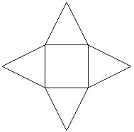

|  |  |
| --- | --- |
| a. | tetrahedron |
| b. | triangular prism |
| c. | square-based pyramid |
| d. | none of the above |

____ 9. Which square will be opposite square A, when this net is folded to form a cube?

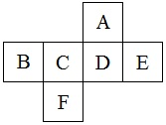

|  |  |  |  |
| --- | --- | --- | --- |
| a. | B | c. | F |
| b. | C | d. | D |

____ 10. Which square will be opposite square F, when this net is folded to form a cube?

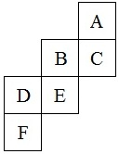

|  |  |  |  |
| --- | --- | --- | --- |
| a. | B | c. | E |
| b. | C | d. | A |

____ 11. Which of the following diagrams represents the top view of this set of blocks?

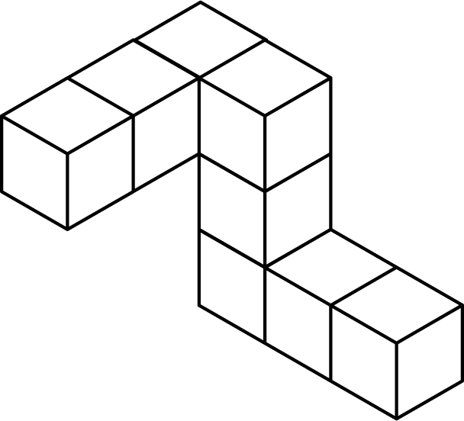

|  |  |  |  |
| --- | --- | --- | --- |
| a. |  | c. |  |
| b. |  | d. |  |

____ 12. Which of the pieces shown is a component of this chair?

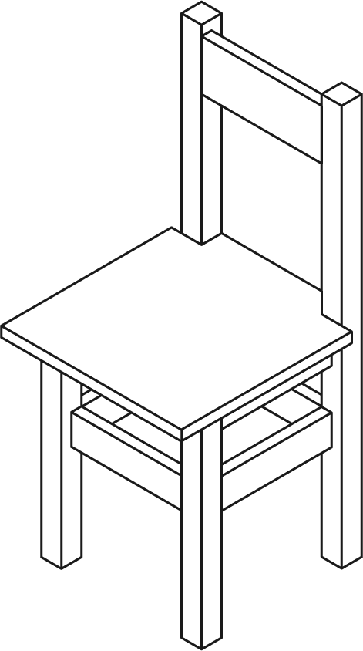

|  |  |  |  |
| --- | --- | --- | --- |
| a. |  | c. |  |
| b. |  | d. |  |

____ 13. This top view matches which set of blocks?

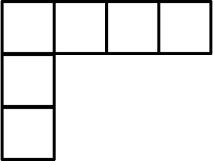

|  |  |
| --- | --- |
| a. |  |
| b. |  |
| c. |  |
| d. | All of the above. |

____ 14. What information about the dimensions of a drawing can be taken from measuring a perspective drawing?

|  |  |  |  |
| --- | --- | --- | --- |
| a. | height and width | c. | height and depth |
| b. | width and depth | d. | height only |

____ 15. In a perspective drawing, where must the object be placed, relative to the horizon and vanishing point, so that the front, left, and bottom sides are visible?

|  |  |  |  |
| --- | --- | --- | --- |
| a. | above and to the left | c. | above and to the right |
| b. | below and to the left | d. | below and to the right |

____ 16. Which of the following statements about perspective drawings is true?

|  |  |
| --- | --- |
| a. | The depth of an object is drawn half as long as the actual length. |
| b. | The depth of an object is drawn a third as long as the actual depth. |
| c. | The depth of an object extends all the way to the vanishing point. |
| d. | The depth of an object is up to the artist’s discretion and estimation. |

____ 17. If the rectangular prism shown in this isometric drawing has the following dimensions, what is the measure of *l*?

*w* = 12 cm

*h* = 8 cm

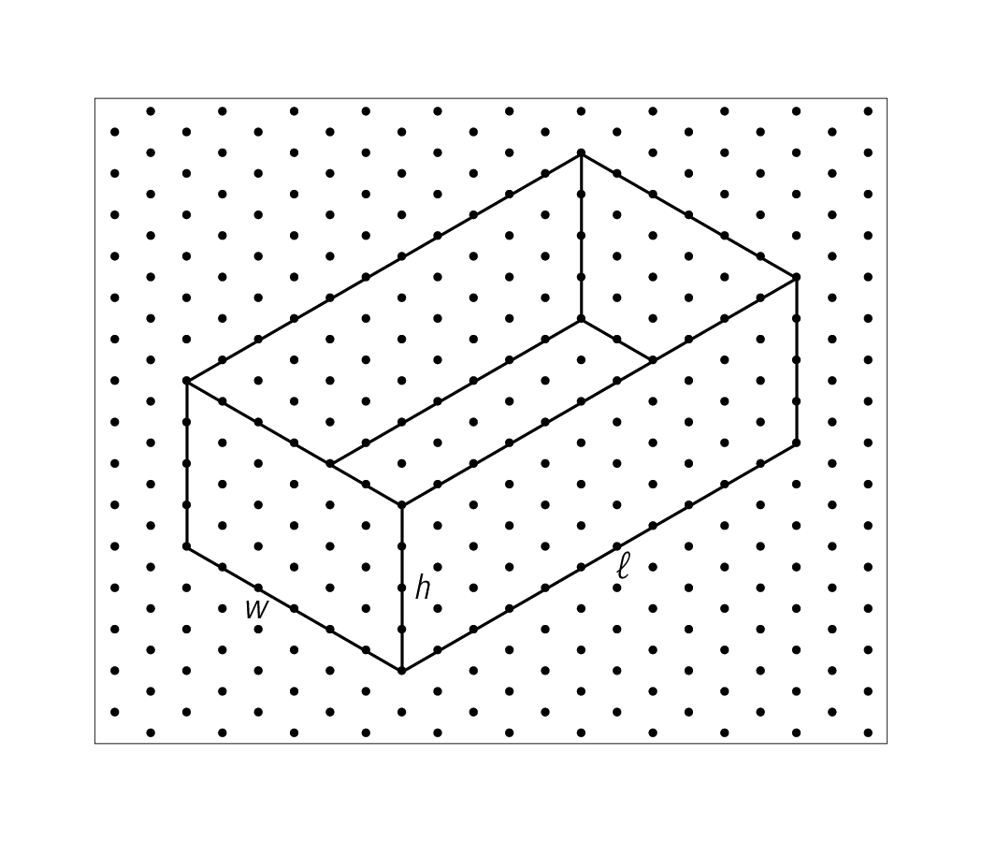

|  |  |  |  |
| --- | --- | --- | --- |
| a. | 22 cm | c. | 18 cm |
| b. | 11 cm | d. | 28 cm |

____ 18. Diagrams A and B show an assembled pencil box. Diagram C shows an exploded diagram of the pencil box.

**DIAGRAM A DIAGRAM B**

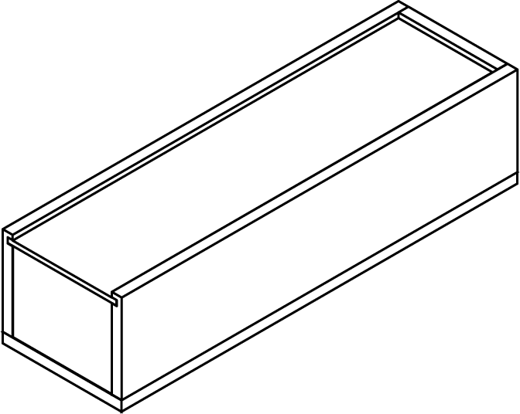 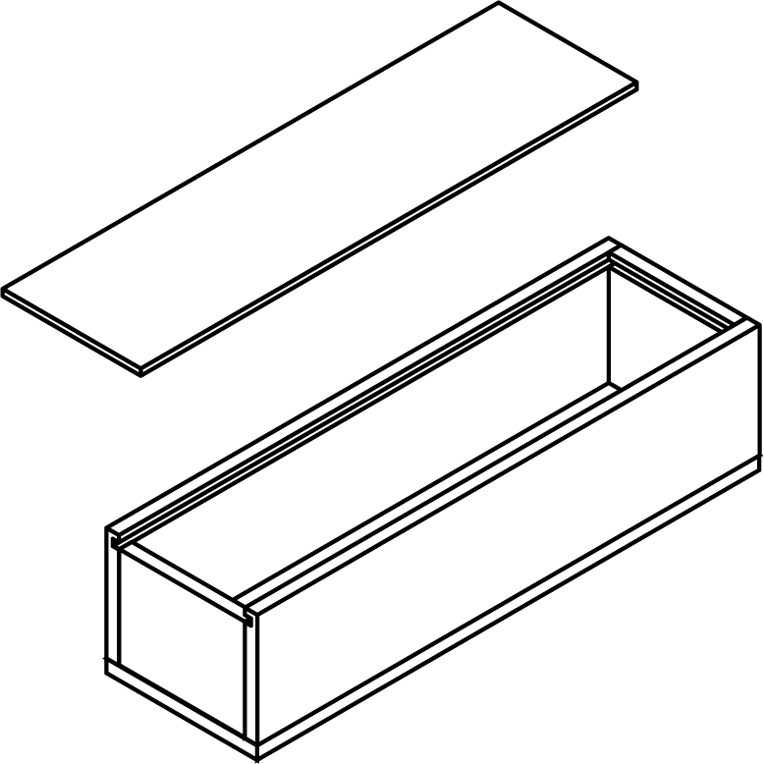

**DIAGRAM C**

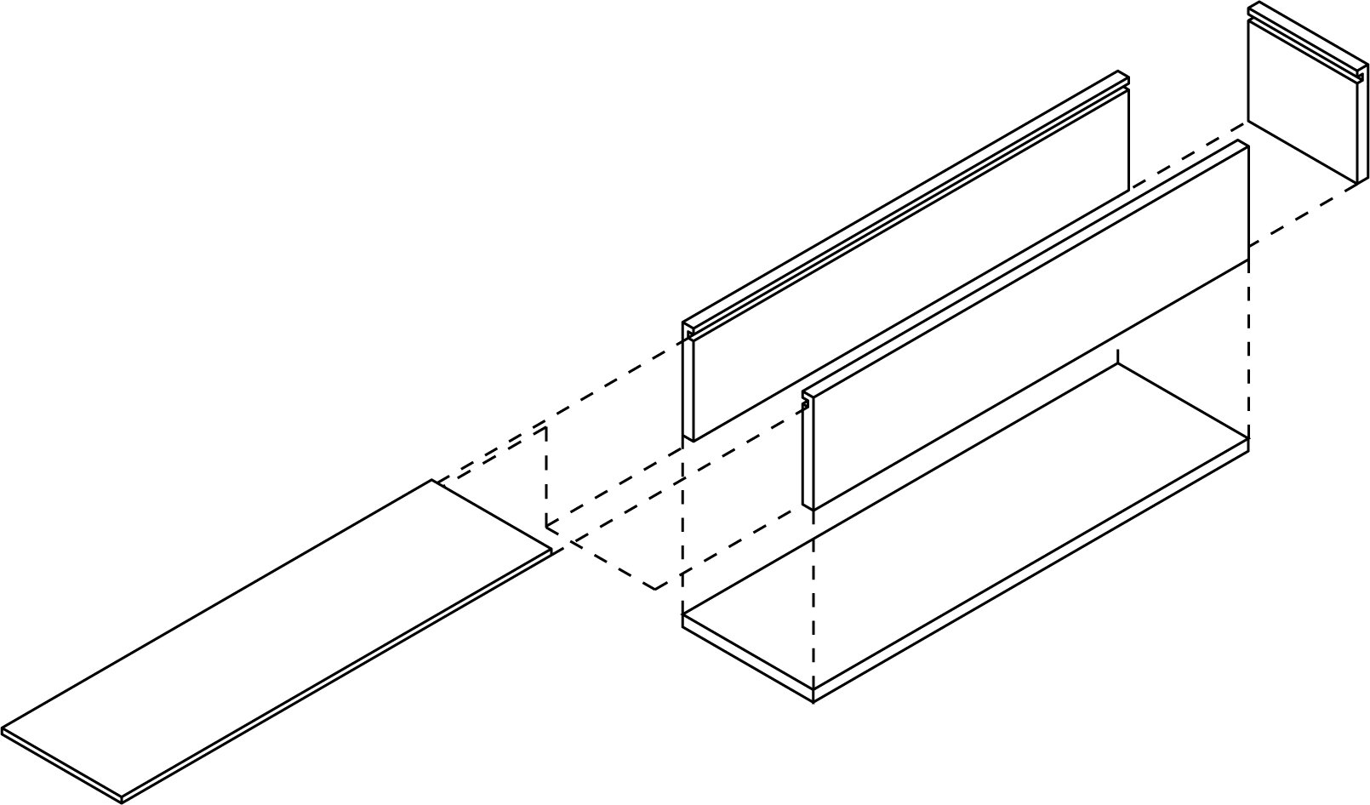

Which of the following pieces is missing from the exploded diagram?

|  |  |  |  |
| --- | --- | --- | --- |
| a. |  | c. |  |
| b. | None of the above | d. |  |

**Short Answer**

1. The scale factor for a blueprint of an office is 1:18. If the blueprint is 1.77 m wide, what is the width of the actual office?

2. The Eiffel Tower measures 324 m from base to antenna. If an Eiffel Tower key chain measures 5.6 cm tall, how many times taller is the tower than the key chain?

3. A storage locker in an apartment building measures 4.5 m deep. A scale model of the building layout contains a storage locker measuring 3.7 cm deep. Write a scale statement for the model locker.

4. The image of a castle is shown on television, measuring 18.1 cm wide by 10.6 cm tall. If the actual castle is 16.4 m wide, how tall is it, in metres?

5. The second diagram is an enlargement of the first diagram. Using the values provided, find the value of the side length *x*.



6. Draw the front and side views of this set of blocks.

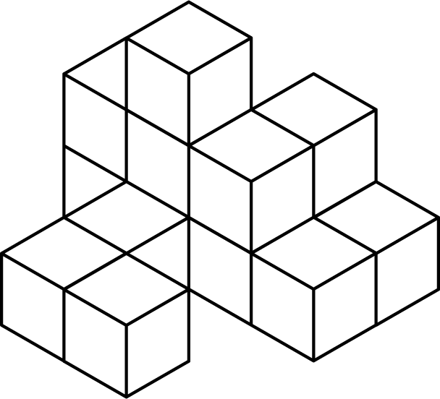

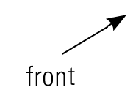 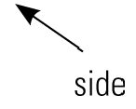

7. Draw the top, front, and side views of this set of blocks.

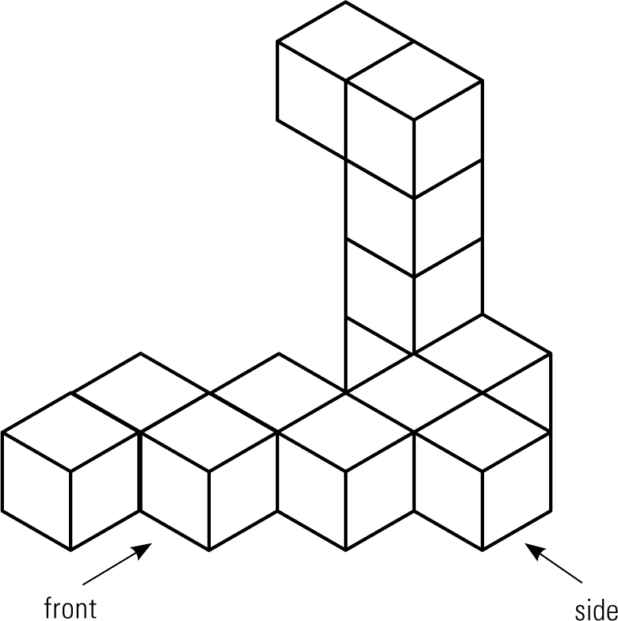

8. Draw a component parts diagram of a rectangular prism that has a width of 4 cm, a depth of 6 cm, and a height of 5 cm. Use a scale of 1:1. Label your diagram.

9. Draw a component parts diagram of a cylinder that has a diameter of 8 cm and a height of 4 cm. Use a scale of 0.5 cm:1 cm for your diagram. Label your diagram.

10. A rectangular box has a width of 2.5 cm, a depth of 3 cm, and a height of 2 cm. Draw an isometric drawing of the box.

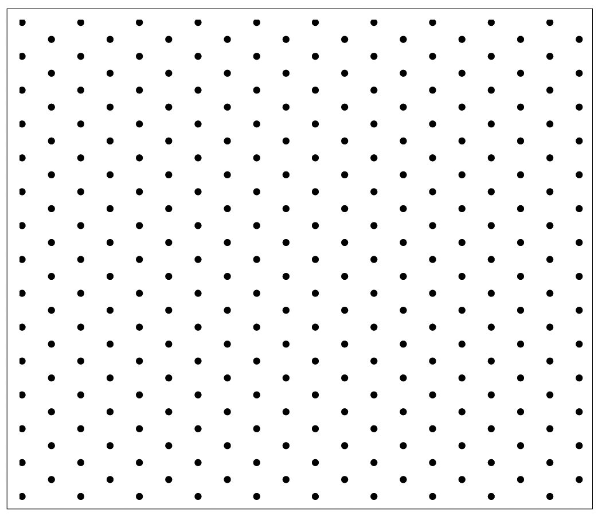

11. The following isometric drawing shows the layout of a living room. The width (*w*) is 25 ft.

a) What is the length (*l*) of the room?

b) What is the width of the doorway?

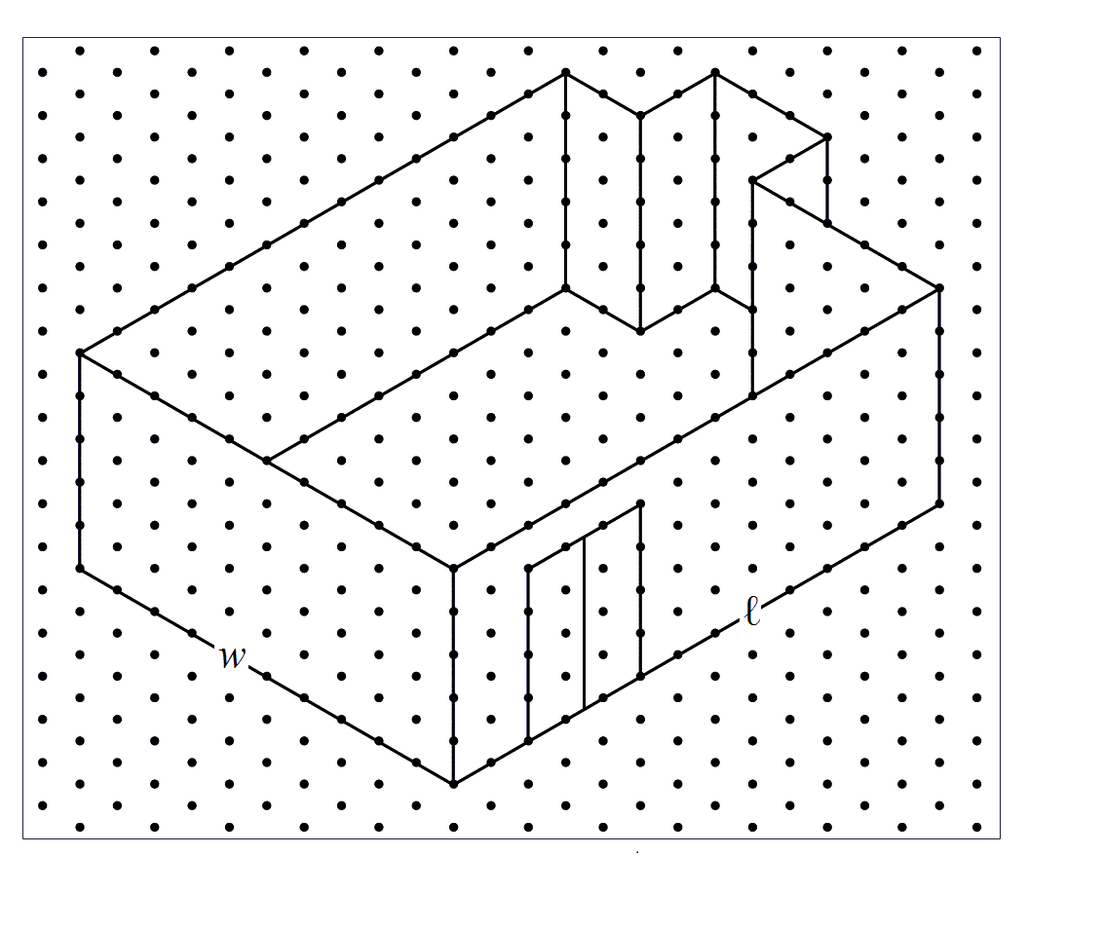

12. Draw an exploded diagram of this spice jar. Under the solid lid shown in the first diagram is a second lid, with holes, as shown in the second diagram.

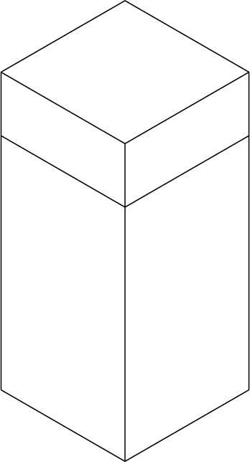 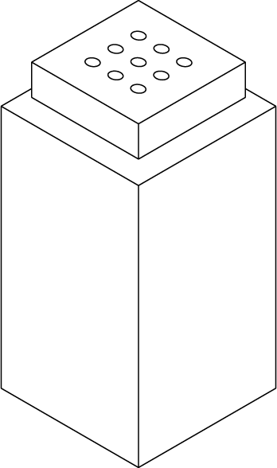

**Problem**

1. A city contractor is working on a project to repave city streets. The drawing below shows a street intersection. If the drawing is scaled by 1:260, what is the area of the intersection?



2. A model of the ‘H’ from the Hollywood sign is shown below. If the scale statement for this model is 1:36, what are the dimensions of the actual sign letter?



3. Draw top and side views of this staircase, to scale. Label the staircase’s dimensions on your diagrams. Write a scale statement for your diagrams.

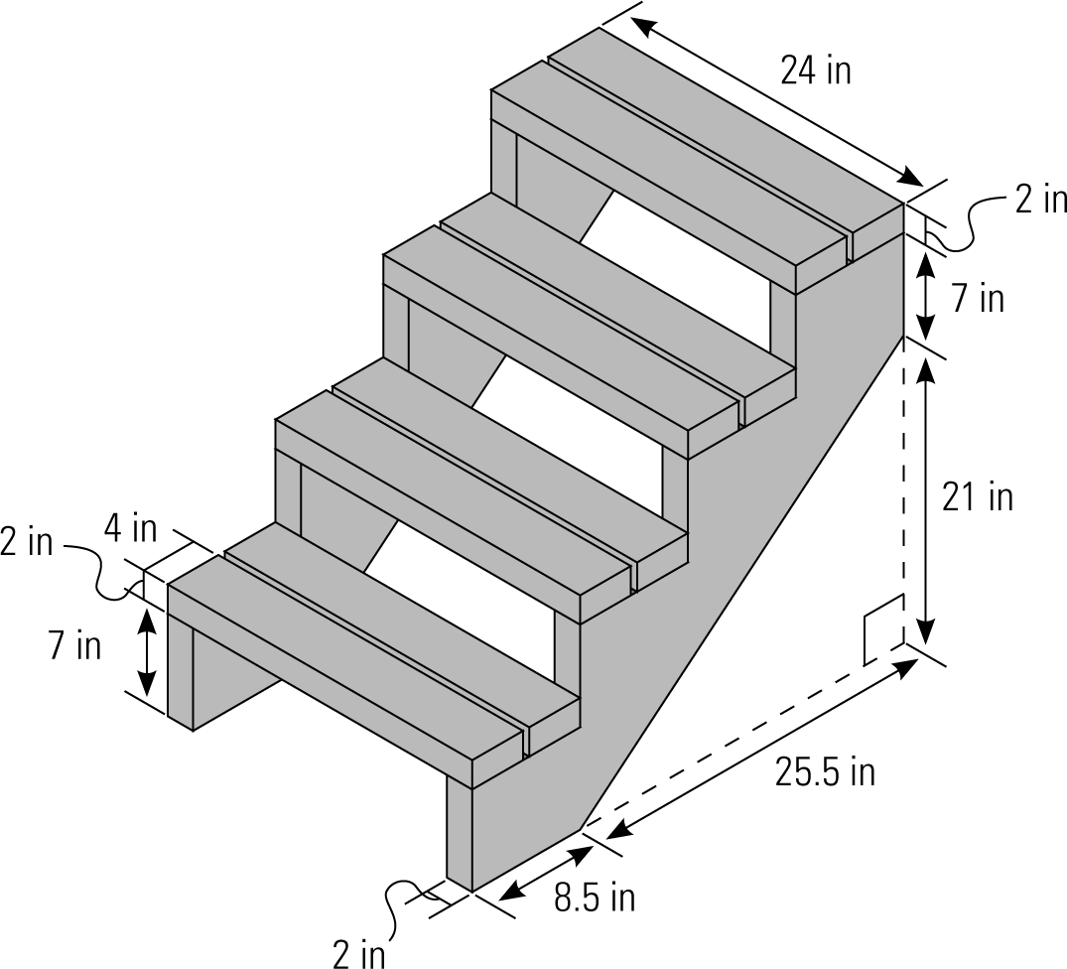

4. a) Draw the front view of this set of blocks.

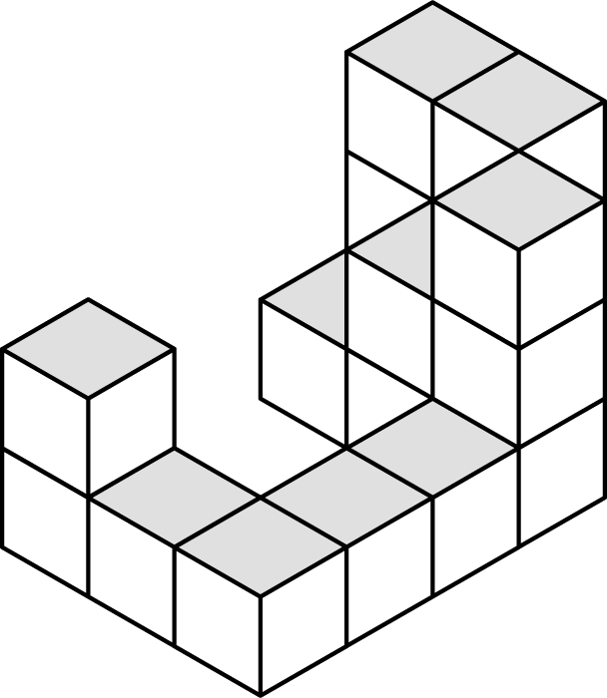

 

b) Do you have enough information to draw the top view? If so, draw it. If not, explain why not.

c) Do you have enough information to draw the side view? If so, draw it. If not, explain why not.

5. Determine the surface area of this rectangular prism, if the height is 3.6 cm.

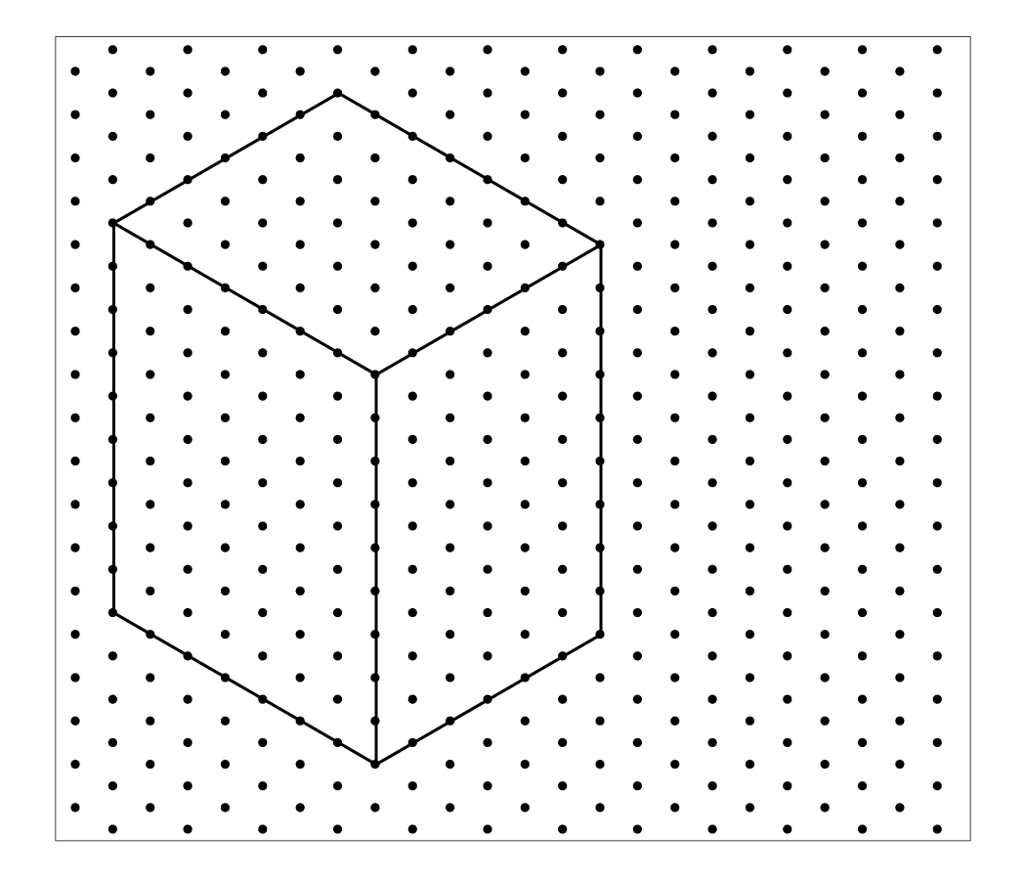

6. The following diagrams show an assembled picture frame and its component parts. Use the information in the diagrams to draw an exploded diagram of the picture frame.

**Assembled:**

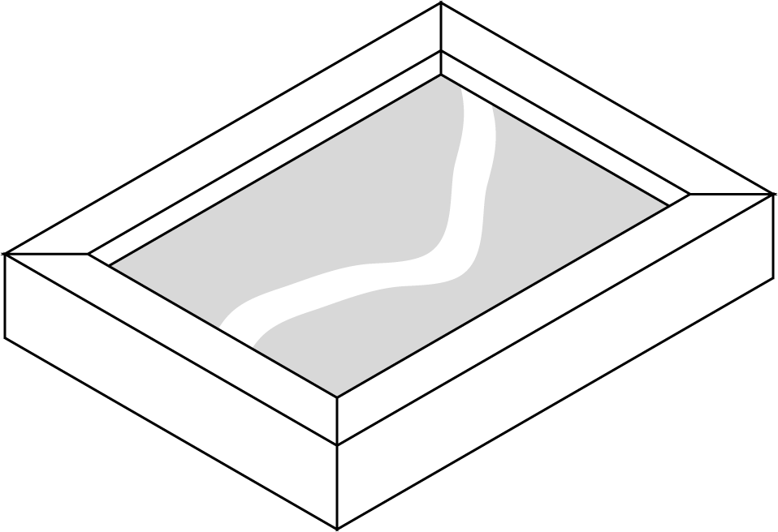

**Component parts:**

